The Two Week Itinerary: Adventures in NY/DC
By Jack Gillispie
July 20
Since I packed the night before, I enjoyed the early hours by eating a lot at breakfast. My family and I drove off to the airport at 8:30 for an 11:30 flight. Navigating the airport wasn’t the biggest issue; it was burning 90 minutes at the terminal, with nothing but a couple bridge books stuffed deep into my carry on. This was followed by a two hour layover in DC, which was easier given the waiting warm up in Atlanta.
I arrived in NY around 3:30 PM. It was a little walk until I could make out my partner’s kippah in the distance. Nathan had proved himself a decent person and player through our previous online practice sessions. In addition, he upheld the title of top tour guide throughout the whole trip.
Bedroom View
When the cab arrived at the apartment, I went through the usual motions of introductions to his parents, getting out my clothes, and determining where dinner was. Once this was done, we went out to explore Central Park until sundown. Apparently the shady characters come out at night.
July 21
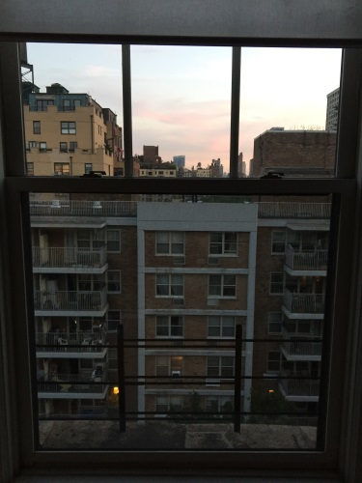
Breakfast included four eggs, half a pound of cheese, and various breads (in other words, not too much). Nathan preferred oatmeal, for reasons unknown to this day. We confirmed what we were doing that day, which included playing at Honors Bridge Club and visiting Times Square.
In order to get to one of the most well regarded clubs in the nation, I had to take the subway for the first time. This was relatively simple, as my understanding of where we were going was adequate. The most difficult thing proved to be passing through the turnstile.
The 1:00 game was directed exceptionally well. Nathan and I played in the lower strata (!) and scored an easy 63% for 1st. I persuaded him to play in the open flights from that time on. After all, what’s the point of traveling 800+ miles to play against beginners? As for the hands, yes, we bid one grand slam that session.
That evening, Time Square proved to be in constant motion. Everywhere I looked, foreigners swarmed to their destinations alongside bold advertisements and street shows. We ended up watching one such show, in which several young men demonstrate their athletic abilities through dancing and jumping over each other. Their interaction with the audience proved to be amusing.
Breakfast was similar to yesterday. The day ahead of us involved a lot of walking, which was oddly more of an issue for my partner than myself.
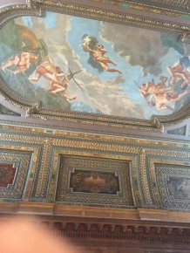
The library was the first place on the list of things to visit. It was huge, crowded, and almost unnaturally quiet in some rooms. The ceilings of some sections were grandly decorated with art, while others were too high up to have anything attached safely. Of course, there were books beyond counting (how many of them were bridge books?).
Library Ceiling
Unable to check out any books, we ventured to the Chrysler building. It truly is bigger in person than the pictures suggest. Unfortunately, going to the top was not an option available to us. So we retreated to a Middle Eastern place down the street. I highly recommend the falafel at Urban Space to anybody in New York. It is not disappointing.
Afterwards, we explored Grand Central Station. It lives up to its name, since there are numerous restaurants and thousands of people that fit in with room left over. Since the falafel wasn’t enough to satisfy my stomach, I got two double chocolate chip cookies to cap it off. This was enough to conclude the touring for that day.
July 22
Today was going to be focused on afternoon bridge. But before we played, we had to explore something…
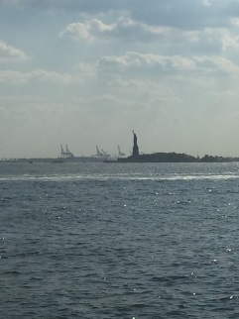
… so we went to Wall Street. It was nothing at all like I expected. No busy marketplace or irate investors. There wasn’t anything particularly special, apart from the presence of the Trump Tower and the famous investment building. There was, however, a great view of the Statue of Liberty from the edge of the land. It was one of the few things I actually photographed on the trip.

Our play in the afternoon game was far from stellar. It seemed that boards like the following were all too common

Board 4  West Deals  Both Vul | ♠ 5 4  ♥ Q 9 7  ♦ A K Q 4  ♣ J 10 5 3
♠ A 2  ♥ 6 4 3  ♦ J 7 5  ♣ A K 7 6 4 | N  W E  S | ♠ K Q J 6  ♥ K J 8  ♦ 6 3 2  ♣ 9 8 2
♠ | 10 9 8 7 3
♥ | A 10 5 2
♦ | 10 9 8
♣ | Q

Sitting EW, we ended up in 5♣ -5. Perhaps my memory is selective, but I do not recall the auction.
Nathan’s cousin came in to visit from Washington for dinner. They welcomed the Shabbat with an excellent meal and mind opening discussions. It was a unique experience, partly due to the novelty of Jewish life, partly due to awkwardly wondering whether I should be reciting the prayers as well.
July 23
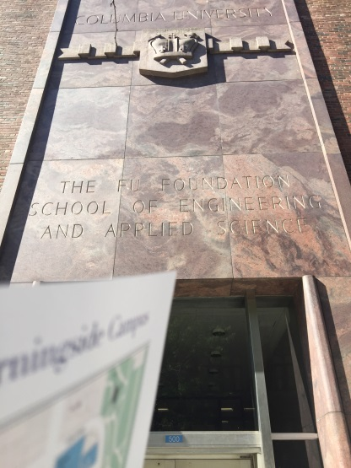
After breakfast, I went out by myself for a scheduled tour of Columbia University.
Well… almost scheduled. The information session was overbooked, so I was not able to get the full experience. However, the size of the campus was enough to take in as is. There’s even a small park to the north of the school. Despite the school’s reputation, I didn’t see myself living there comfortably. Maybe that’s just the southerner in me crying out against the Yankees.

After lunch (a croissant) at the Hungarian Pastry Shop, Nathan’s family and I toured the Met. It was nothing short of spectacular. I particularly liked the impressionist paintings they had on display. However, the two best things on display were the Manhattan skyline at the top of the building, and the pedestrian water fountain at the main level.
Dinner was at this odd Asian restaurant, Wa Jeal Sichuan Chili House. It was good food, and a necessary step in preparing Nathan for tomorrow’s fast. We hastened the “loading” process by going to Serendipity afterwards. Apparently they are famous for their various ice cream dishes and atmosphere. Despite the half hour wait, Nathan and I gladly enjoyed the deserts they offered. However, I think the restaurant’s reputation is a little inflated
July 24
For reasons still clearly not understood to me, Nathan was fasting the entire day. I had to respect his dedication to faith as I wolfed down another four eggs. Today was going to be two sessions at Honors, so I had to prepare myself mentally. What better way to do this than visit the 9/11 memorial?
Those who haven’t been to the memorial are most unfortunate. I was literally speechless as I observed the remains, which included fragments of the building as well as the lives of the individuals. The most moving exhibit is definitely the large fountains on the outside of the building. The names of all who passed are etched into the edges. It’s phenomenal.
I leave it to the reader to infer why I’ve chosen not to express the results of our games at Honors.
July 25
The day was really mundane, with two small exceptions.
First and foremost, we visited Smorgasburg. It was relatively quiet as Nathan hustled me in foosball. There were not as many vendors as there are normally (8 as opposed to 40). I talked myself into ordering only a serving of truffle French fries. It was, in a word, filling. I only got halfway through.
Second, I started really meeting some of the great players. Nathan and I played against Yuan Shen and his friend. I got his contact information afterwards. I also chatted and got information from three other professionals, one of whom discussed hands with us through midnight! Apparently the pro-client relationships make for interesting bridge stories.
July 26
This was the last day I had in New York. It was necessary that Nathan and I break 50% in the open pairs, in addition to the fact that I renew my love affair with exercise. There was no gym with an appropriate price tag, in addition to the time constraints of my to-do list. Accordingly I spent the morning running around the lake in Central Park. Oddly enough, I think this was the best thing that I did the entire trip. Maybe it was just the endorphins that made it all seem so memorable…
The family and I also made time to play tennis out on the courts in the park. I suspect my racket was too small, since I kept loosening my grip and hitting the ball way too high as a result.
In the afternoon, Nathan and I did have a 55% game in the open field. I was still personally disappointed, but Nathan was happy, and that’s all that mattered.
July 27
Today was the day we packed our bags and headed for Johns Hopkins, en route to D.C. It turned out to be quite an exhausting day. I suspect this is mainly due to the ride there in the train, but who knows.
The tour/info meeting at Johns Hopkins took about two hours total. Our tour guide was great, and apparently skilled at walking backwards. He emphasized the education quality and heavy student influences in both curriculum and extracurricular activities. This, by no coincidence, coincided with the presentation at the info meeting. Unfortunately, I didn’t see myself living in Baltimore. Not for my undergraduate studies, at any rate. Nathan, however, who enjoyed the Jewish life and academic freedom, found the school to be quite a fit. It isn’t his top school, but it’s in the consideration pool.

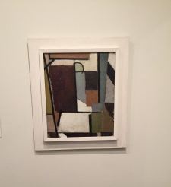
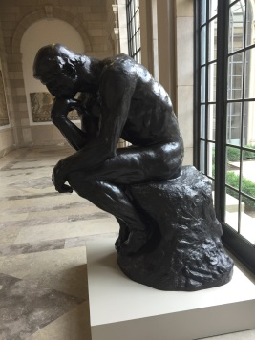
After seeing the tour and the Museum of Art, we headed to Nathan’s mom’s friend’s house for dinner. Her son is an excellent cook, but I wouldn’t recommend anybody go over to their house uninvited.
We unpacked our suitcases at yet another friend’s house. Apparently this gentleman was selling his house, and allowed us to reside in it for the remainder of our stay. It was a little weird considering that he was never there. This was probably due to his job, which frequently took him overseas for long periods of time.
July 28
The Mariott was only a 20 minute walk from where we were staying. The only thing stopping us was Nathan’s need for sleep, which had us leaving at 9 instead of an earlier time. I advocated early departure as a means for meeting more people. Fortunately I made due with the time I had.
We found the room upstairs hosting the youth events. Needless to say it was filled with kids our age and younger. As it is appropriate to do so in these situations, I found myself in a meet and greet with just about everybody. Many of these folks were old bridge friends, others were complete strangers, and many were bridge acquaintances whose names I hadn’t remembered. Among the important friends are Jason Miller, Ellie Fashingbauer, Reese Koppel, and of course, our teammates Jonathan Baumel and Gianni Hsieh. Listing everybody would require a publishing contract.
The main event that day was pairs, followed by a Swiss event. Both ran about three hours despite the minimal number of boards played (only 16!!). Nathan and I ran into several interesting pairs, the most friendly being the Canadians (all of which now have my contact information). We took 3rd in the pairs and 6th in the teams. I was, simply put, embarrassed with our results, but there was nothing to be done about this except to outplay ourselves in the following days.
That evening we tried our luck in the B/C/D teams. Placing 7th in B, 2nd in C was equally disappointing.
July 29
This felt like a repeat of the day before. Nathan and I qualified in the pairs with 3rd place, and sank in the finals at a contemptible 46%. Fortunately, our teammates took 2nd, which was a little reassuring in light of tomorrow’s team competition. Plus, it was a little more bearable due to our marginal victory over them in the qualifiers.
As is common at nationals, all the kids casually grouped together and discussed what crazy bidding and play had taken place at our tables. It’s a common joke among the better youth players that the pairs events are so random that it is merely a warm up for the following Swiss events.
What made this competition so curious was the amount of Chinese players. Many of them knew only adequate English, but their intentions spoke clear as they berated each other after, quite literally, every hand.
July 30
This was the last day of the youth NABC, and the penultimate day of the NABC. I found myself listening to the Rocky theme song as Nathan and I walked down to the Marriott from our place. After embarrassing myself twice, I resolved to go in and mop the floors. This was the last chance I had to do something earth shattering, so it was truly now or never.
The reader may now decide what might have influenced the results of this day. In the morning we took first soundly, hoarding our 20 VP carryover. We proceeded to bend over and take 11th overall in the afternoon. It was truly the closet I have ever come to being unglued. Fortunately, I have a disposition similar to my dad in which I get over disasters very quickly. This was a lot easier when Ellie and I went out for a swim after the afternoon session. A laid back girl, she and her team performed well enough to sympathize with us but still enjoy some sense of victory. I suspect our personalities are very similar, and so we are in talks in competing in future tournaments.
This was followed by playing in the evening Swiss events and Midnight Zip Knockouts. We took 2nd in B & C, edging out our fellow youth competition (phew). It’s amusing, since we had tried to arrange it so that we would directly play against them, but this was not the case.
In the KOs, the highlight event of the entire tournament, it is customary to use borderline ridiculous methods to achieve absolutely absurd results. Nathan and I elected to try a tame variant of EHAA. In this system, one level openings are unlimited and forcing, 1N is 10-13, and 2 level openings are all 5+ card suits with 5-12 HCP. These openings are mandatory, which further adds to the fun of the bidding. Our teammates, for reasons unknown, were not so creative. They stuck to traditional 2/1.
We beat the first team. Then, we tied the second team, but lost the two board heat. Unfortunately, this meant forfeiting bragging rights that we beat Joshua Donn’s team. Oh well.
This was made up for by the following discussion with our opponents. The gentleman whom I conversed with has trained almost every professional player in the top 400. I had actually read most of his articles (though I’m not convinced I remember all of them!), which he found was good enough reason to offer me some advice, in addition to his email. I’m expecting a lot of great opportunity in the foreseeable future.
The remainder of the evening was spent socializing with other youth players, in addition to kibitzing the casual annual money bridge game that Arjun Dhir, Sam Amer and company play. Needless to say the bidding and play was quick and exciting.
August 1
After four hours of sleep and half of a hot challah, I thanked Nathan and his mom for their incredible hospitality as I exited to kibitz briefly the morning Swiss. The last thing that I remember was Jess Chao and Arjun Dhir being -3 on their first round. Their outcome solely depended on the fatigue of their competition. I’d put my money on those folks almost any day of the week.
The train ride to the airport was dull, and the extraneous wait at the airport was even more overcast. However, I did run into Jim Fordham, a good player that I had seen at various events in Atlanta. When we both missed the flight due to the attendant’s lack of volume, we found that we had each met another decent bridge player in need of good tournament partners. He is currently in recess from bridge pursuing other hobbies (thank goodness he is still sane), so it could be awhile before I see him playing across from me.

*Author’s Note: The order of these events may be obscured due to memory affected by a lack of sleep and an excess of Five Guys’ Burgers
