About Bridge Office Hours:
Every Sunday from 6pm-9pm, any bridge player with a Bridge Base account may log on and play with or against me. Any bridge questions will be answered on a live video stream. These questions need not be related to the hands being played – they can be problems that happened from a previous game or a general question that has been left unanswered.
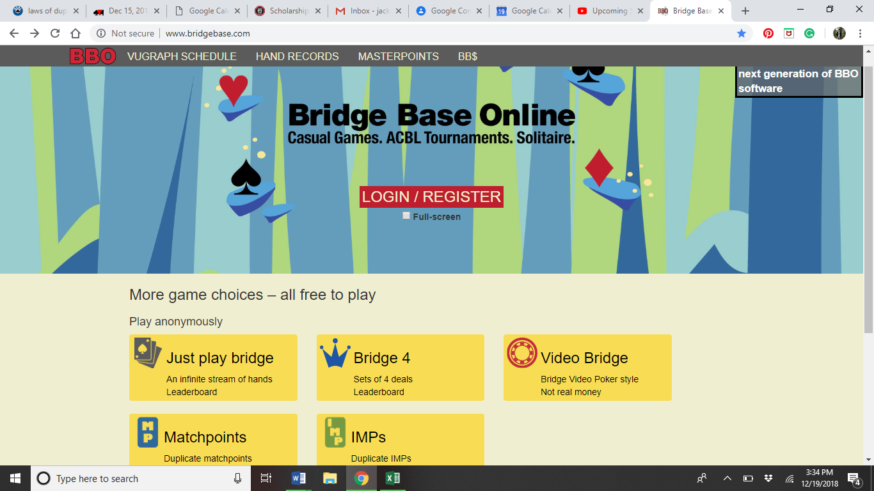
Monthly membership costs $25. For the price of playing at the club once a week, you can improve your game exponentially. Give it a try! If you do not have a Bridge Base account, instructions are provided below.

Click on the red Login/Register Button

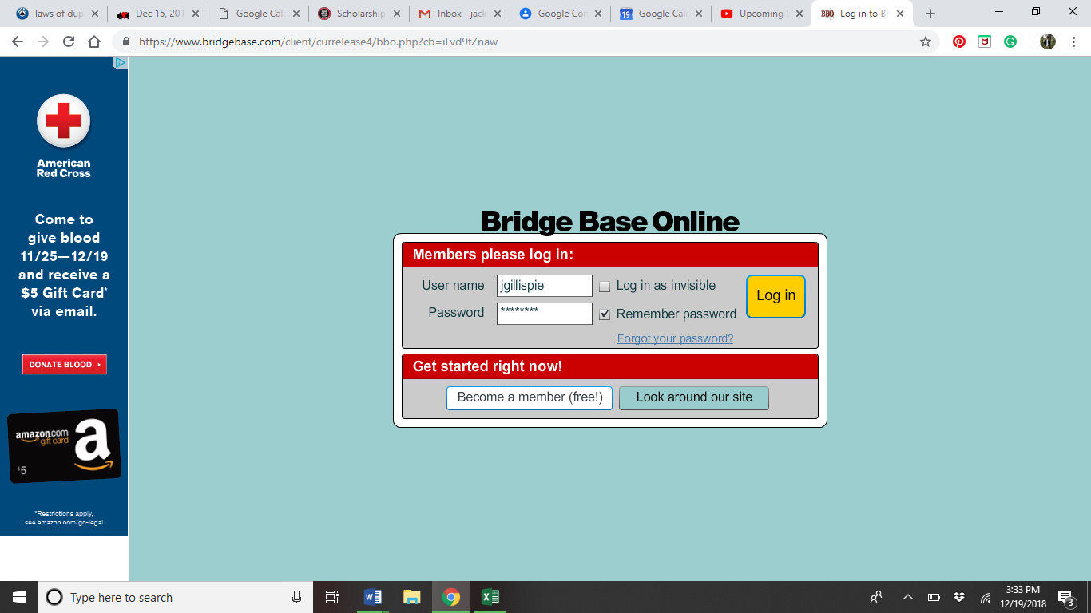

Click on the blue Become a Member Button

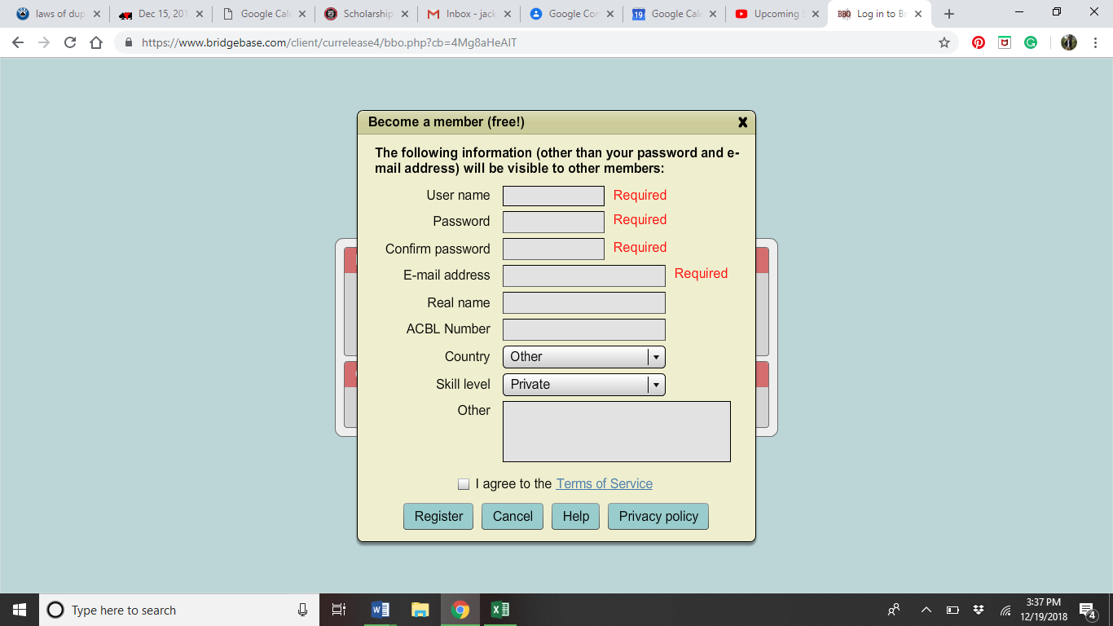

Fill in the info, check “I agree” and click the blue Register Button

